Module Assembly - NASA SMG NodeJS API version Deployment Guide

Revision History
Author | Revision Number | Date
TCSASSEMBLER | 1.0 | 09.03.2014

Deployment Instructions 3
1. Organization of Submission 3
2. Application Technologies 3
3. Application Setup 3
4. Configurations 4
4.1. Database setup 4
5. Deployment Instructions 5
6. Verification 6
7. Resource Contact List 10

Deployment Instructions

Organization of Submission

nasa-smg | Main application directory
nasa-smg\config | Contains configuration files.
nasa-smg\controllers | Contains controllers
nasa-smg\downloads | Contains upload files.
nasa-smg\errors | Contains definition for error objected used in application.
nasa-smg\helpers | Contains helpers and utilities.
nasa-smg\models | Contains models
nasa-smg\sql | Contains sql files, which create the foreign key or unique constraints
nasa-smg\.env_sample | The sample environment configuration
nasa-smg\.gitignore | Represents ignored files for git
nasa-smg\app.js | Main application entry.
nasa-smg\config.js | Configures express app.
nasa-smg\db.js | Load db and initialize models
nasa-smg\generateData.js | Script for generating sample data.
nasa-smg\package.json | Module dependencies for application.
nasa-smg\postman.json | Contains definition for API routes for postman chrome extension.
Module Assembly - NASA SMG NodeJS API version 1.0.doc | This file.

Application Technologies
- Node.js 0.10 http://nodejs.org/
- Postman
- MySQL

Application Setup

Install latest version (0.10.x) of node here http://nodejs.org/
Install MySQL from here http://dev.mysql.com/downloads/
Install postman extension to chrome browser from here https://chrome.google.com/webstore/detail/postman-rest-client/fdmmgilgnpjigdojojpjoooidkmcomcm/related?hl=en

Configurations
Copy file .env_sample to .env and set below properties. Probably you can use default configuration.

Name | Description | Default value
DB_HOST | The host for MySQL server. | localhost
DB_NAME | The MySQL database name. | nasa-smg
DB_PORT | The port for MySQL server. | 3306
DB_USER | The username to login to MySQL. | root
DB_PASSWORD | The password to mysql server. | <empty>
RESET_TABLES | The flag if recreate database. It will drop and create again all tables. Test data is not inserted. Tables will be reset each time you run node app. | false
DOWNLOADS_DIR | The path to directory where files are downloaded. If not set then files are downloaded to nasa-smg/downloads. | <empty>
PORT | The port which application listen to. | 3000

To apply configuration run:
. .env
Before running node app command (or any other scipt).

Database setup
You must create only empty database in mysql server. Default database name is nasa-smg. Application will create all required tables.

Deployment Instructions
- Run npm install in directory <submission>/nasa-smg
- Setup configuration .env file if needed. See section 4.
- Run node generateData.js to create all tables and insert test data.
- Run node app. Server listen on http://localhost:3000 (by default)
- Setup postman.json file
  - Open chrome-extension://fdmmgilgnpjigdojojpjoooidkmcomcm/index.html
  - Click import collection
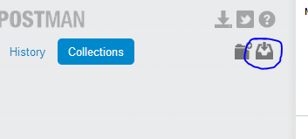
  - Choose file postman.json and close dialog.
  - Collection is imported now.
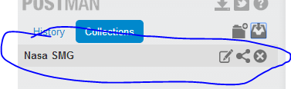
  - Go to environments settings.
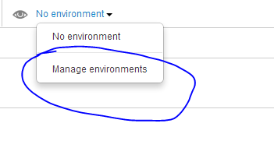
  - Set global value URL to http://localhost:3000. (change port if you are using different)
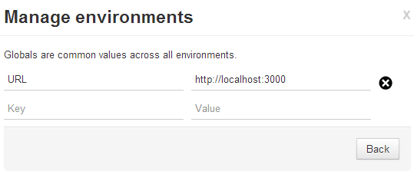
  - Now you can test API methods.

Verification

First short description about my solution.

I have implemented CharacteristicValueType as described in this post http://apps.topcoder.com/forums/?module=Thread&threadID=812457&start=45&mc=62#1853258

SMGCharacterstic have fields: value and valuetype_id. Both are optional.

SearchFormFieldValue have fields: value and valuetype_id. Both are optional also (they can be null on same time, I didn’t limit that).
If SearchFormFieldValue#value is not null then it will matched to the SMGCharacterstic#value
If SearchFormFieldValue#valuetype is not null then it will matched to the SMGCharacterstic#valuetype

Cascade delete is allowed only if SMGCharacterstic is not affected. That means if SMGCharacterstic is referencing entityX then entityX can’t be deleted. Except the case when we want to remove SMG entity, then all references values will be cascade deleted (it makes sense in Work Flow).
CharacteristicType can’t be deleted if is referenced by Characteristic.
CharacteristicTypeValue is cascade deleted if we delete the CharacteristicType
SearchFormField and SearchFormFieldValue are cascade deleted if we delete the Characteristic
Example#smg_is is set to null if we delete the SMG.

There is also update validation. For example
SMGCharacterstic has reference to Characterstic and CharactersticTypeValue. CharactersticTypeValue must be children of Characterstic#.type_id (CharactersticType). In this case we can’t update CharactersticTypeValue.type_id in CharactersticTypeValue API, because it will make SMGCharacterstic record invalid.

Test data (refer to genedateData.js)
SMG 1:
Summary: 'ok' (textbox value)
Deliverable Type: Knowledge (dropdown value – enum)
Tags: Red, White (2 values, selected 2 checkboxes)

SMG 2:
Summary: 'bad'
Deliverable Type: Technology
Tags: Black

SMG 3:
Summary: 'unknown'
Deliverable Type: Technology
Tags: Black, Yellow

Predefined Search forms (See endpoints Search#1 – Search#6)
- Summary must be ‘OK’
- Deliverable Type must be Technology
- Tags must be Black
- Tags must be Black or White
- Tags must be Red and White
- Tags must be Yellow AND Deliverable Type must be Technology (2 field)

There are many endpoints in postman and they are pretty straightforward.
Few notes:
- In batch methods, first all values are validated. If any value is invalid then error is returned. Valid values are not updated in this case.
- Update methods don’t need to define all properties. If some property is not set then it won’t be updated.
- Search methods support all field (except id field)
- Delete methods return deleted entities.
- CharTypeValue means CharacteristicTypeValue

Sample calls
Get ALL SMG (SMG – view all)
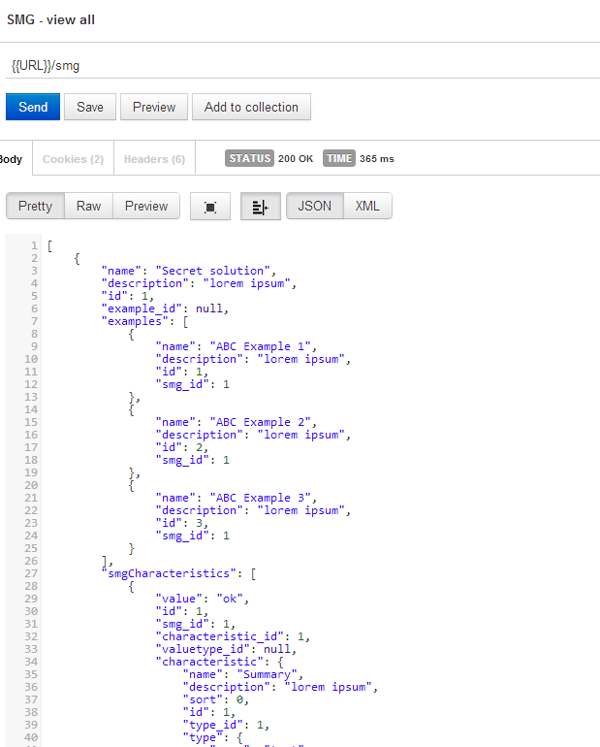

Get all examples by smg 1 (Example – search)
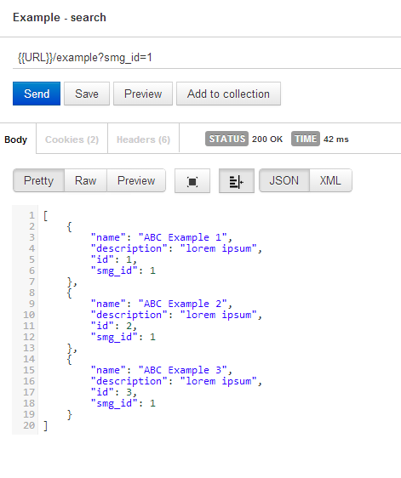

Search by active filter (Search by active), it’s same as Search#1.
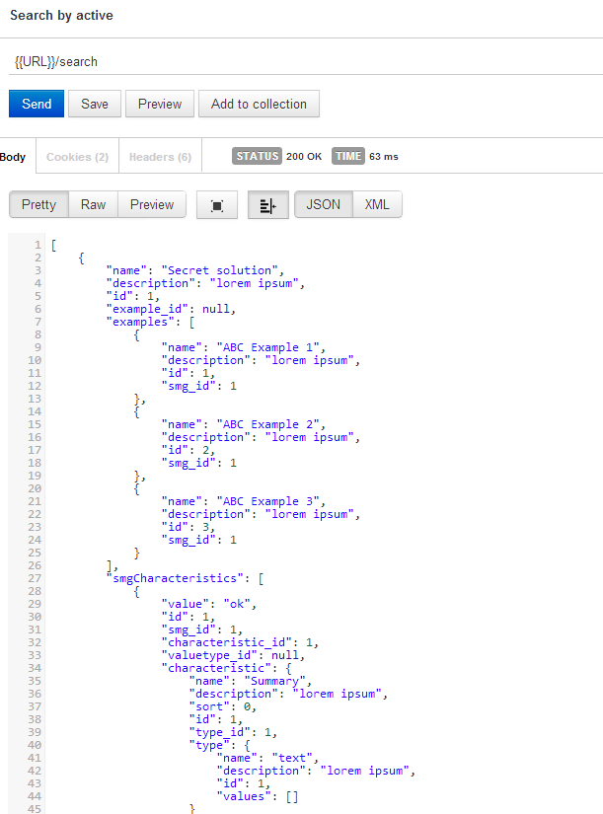

Delete ALL SMGs (SMG - delete batch)
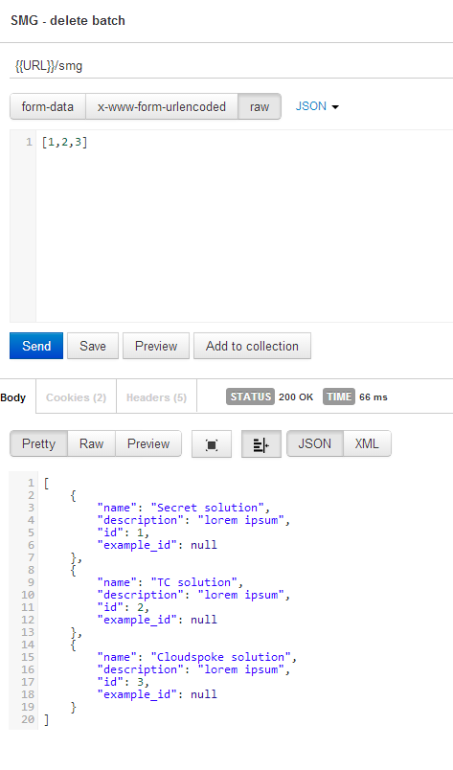

Get all SMGCharacteristic (SMGCharacteristic - view all)
It should return empty list, because we removed all SMGs in previous steps
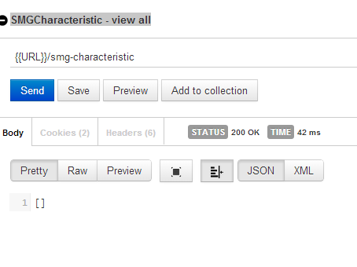

Create HelperTopic (HelperTopic – create)
It allows to upload any file.

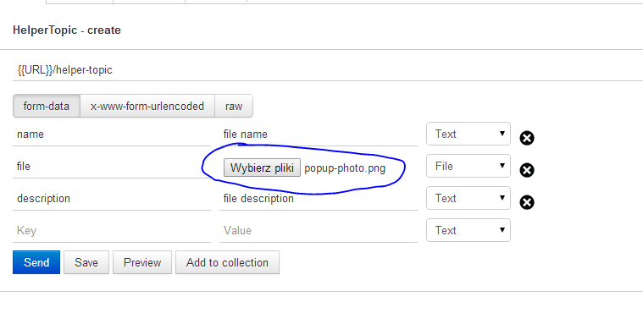
Choose a file (This text means ‘Choose a file’)

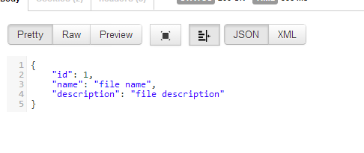
File can be downloaded in different API.
HelperTopic – download
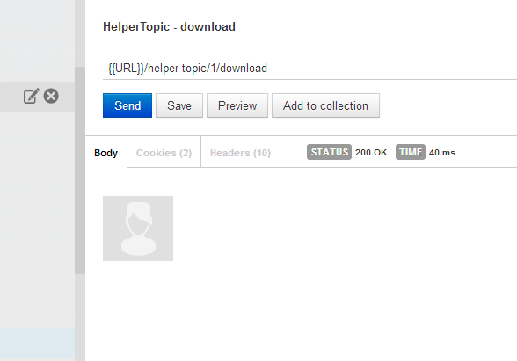
If mime type is set correctly then Postman render it

Resource Contact List

Name | Resource Email

